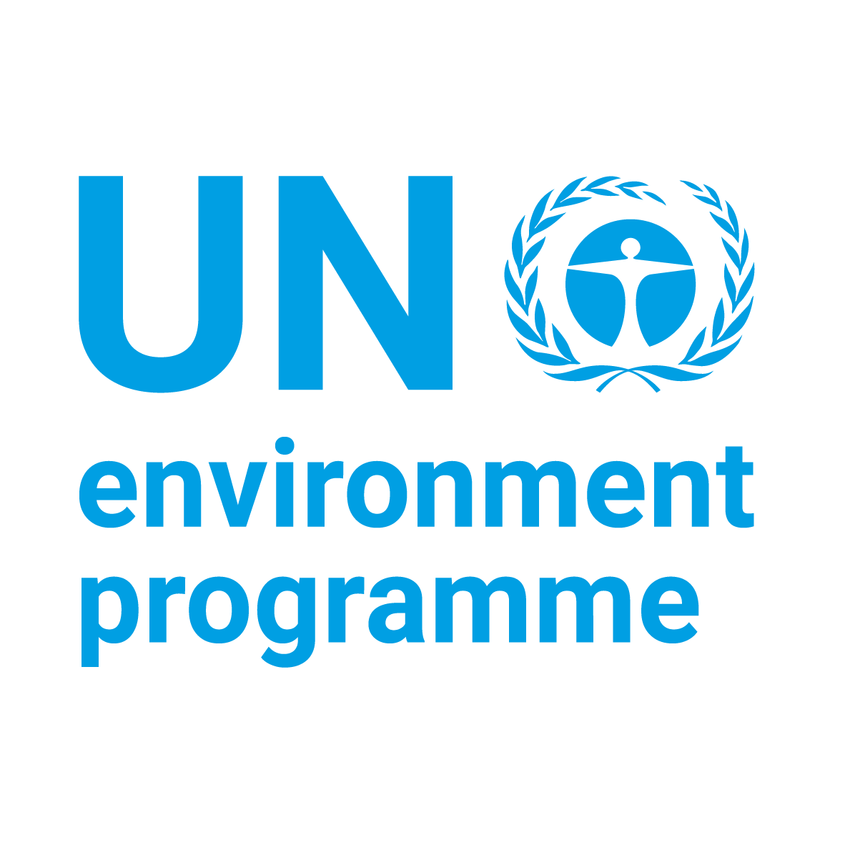

United Nations Environment Programme (UNEP) and International Coral Reef Initiative (ICRI)

Small Grants Programme 2021

CONCEPT NOTE TEMPLATE

(4 pages maximum, including cover page)

Project title:

Intervention country:

Applicant:

Name of Organization: |  | Website:
Name of contact person: |  | E-mail:
Position: |  | Skype ID:
Full Address: |  | Tel:
Are you an ICRI member?

For NGOs
Date of creation:
Country of registration:
Registration number:

THE PROJECT

Title:

Which ecosystems is the project addressing:
(Coral reefs, mangroves, seagrasses)

Brief summary of the project, issues to address and the planned intervention strategy:

(Provide a 4-5 sentence ‘elevator pitch’):

Precise location:
(Country, region/province, town/villages. Add a small map showing the location of the implementation area within the province/region/country)

Project Objectives:
(Primary and if/as relevant secondary project objectives)

How will planned activities achieve project objective(s)?:
(Provide a simple Theory of Change)

How will you measure success?:
(For the situation/problem that your project will address, what is the baseline? What improvements are expected and how will these be quantified? E.g. in terms of impacts on biodiversity conservation, sustainable use of natural resources, resilience to climate change or provision of ecosystem services)

Explain briefly why this project is innovative:

How will you ensure stakeholder engagement?:
(Describe how stakeholders, including e.g. local communities and the private sector, will be engaged)

How will you ensure sustainability of the project and what is the potential for replication?

Total estimated budget (in USD):

Do you have co-financing?:
(If yes, identify the source and estimate amount)

Other Partner(s):
(Identify core partners and briefly describe their role in the project)

Requested start date: Expected completion date:

